Sharepoint Front end

## **Uploading photos to polynet,**

1. Create a folder in my pictures named Upload to Polynet.
2. Filename must be topnz_username (topnz_riftha).
3. Ensure file name is in PNG format.
4. Install Com.CodePlex.SPC3.ProfileImageUpload and configure it according to the picture shown below.
5. Always make sure that the folder that you created in the first step (Upload to Polynet) is kept empty after you have finished uploading your pictures. This is because all pictures in the library will be uploaded to Sharepoint every time you upload something.
6. Sharepoint creates three file sizes and uploads them to the image library.

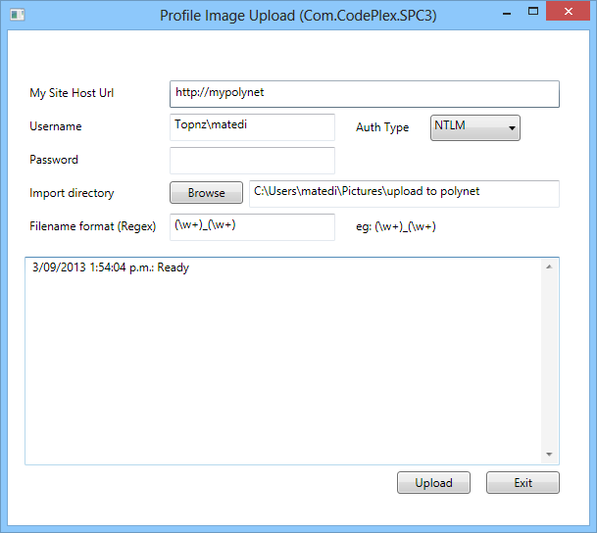

## **Resource Booking, adding a new resource item,**

1. Click on resource bookings and select book a resource.
2. Click on all site content and select resources under the heading “lists”.
3. Scroll down to the bottom and select “add new item”.
4. Type in the name and description and click on save.
5. Please type in the asset number in the description bit while adding resource.